Contents
1. ASK 2
2. PREPARE 2
3. PROCESS 3
3.1 Importing data 3
3.2 Data’s integrity steps 5
3.2.1 Duplicate and corrupted identifiers 5
3.2.2 Missing values 5
3.2.3 Categorical data validation 5
3.2.4 Date range validation 6
3.2.5 Trip duration validation 6
3.2.6 Data transformation 6
3.2.7 Verifying that the data ready for analysis 7
4. ANALYZE 7
4.1 Descriptive analysis 7
4.2 Monthly analysis 10
4.2.1 Overall Travel Trends 10
4.2.2 User behavior (member vs. casual) 10
4.2.3 Average trip duration 10
4.2.4 Duration trends by month 11
4.3 Seasonal Analysis 11
4.3.1 Number of trips 11
4.3.2 Average trip duration 11
4.3.3 User behavior by season 11
4.4 Bike Type Analysis 11
4.4.1 Bike Type Usage (Volume) 11
4.4.2 Behavior: Trip Duration 12
4.4.3. Overview by bike type 12
4.5 Summarize insights 12
5. SHARE 14
6. ACT 14
6.1 Final Conclusion 14
6.2 Top 3 Business Recommendations 15
6.3 Next Steps 16

- ASK
Background: Cyclistic is a bike-share company in Chicago. The company wants to grow by increasing the number of annual memberships, since annual members are considered more profitable than casual riders. To support this goal, the marketing team needs to understand how casual riders and annual members use Cyclistic bikes differently.
Business Problem: Cyclistic needs to increase the number of annual members. However, before creating an effective marketing strategy, the company must understand the behavioral differences between casual riders and annual members.
Business Task: Analyze historical Cyclistic trip data to identify how annual members and casual riders use bikes differently. The goal is to support the marketing team in designing strategies that can convert casual riders into annual members.
Key Stakeholders:
- Lily Moreno, Director of Marketing — responsible for marketing strategy and campaign direction.
- Cyclistic Marketing Analytics Team — responsible for data collection, analysis, and insights.
- Cyclistic Executive Team — responsible for reviewing and approving the final recommendations.
Why This Analysis Matters: The insights from this analysis can help Cyclistic identify usage patterns across customer types and build targeted marketing strategies. Understanding when, why, and how casual riders use the service differently may help the company convert them into annual members and improve long-term profitability.
- PREPARE
Data Source: The dataset was obtained from the public Divvy trip data repository referenced in the case study materials. I selected the previous 12 months of trip data files to match the project requirement and to support a full-year comparison of rider behavior.
Data Location and Storage: The monthly trip data files were downloaded as ZIP archives from the source repository, stored in a raw-data folder, and then extracted into a separate working folder for further processing. Original downloaded files were preserved to maintain a clean audit trail.
Data Organization: The dataset is organized into separate files covering individual time periods within the 12-month analysis window. Each row represents one bike trip, and the columns describe trip attributes such as ride ID, bike type, start and end timestamps, station information, and rider type (casual or member). For the final analysis, these files can be combined into a single dataset to allow full-year comparison.
Data Credibility and ROCCC: The dataset is reasonably credible for this case study and generally follows the ROCCC framework. It is reliable because it comes from a recognized bike-share data source used specifically for this project. It is original in the sense that it reflects actual trip records rather than secondary summaries. It is comprehensive enough to support behavioral comparisons between rider types because it includes trip timing, station, and user category data across a 12-month period. It is current enough for educational analysis within the case study context, and the source is clearly cited in the project materials. However, the data is not perfect for broader customer profiling because it does not include demographic or personally identifiable information.
Privacy, Licensing, Security, and Accessibility: The dataset is publicly available and can be used for analysis within the scope of this case study. At the same time, privacy restrictions apply: personally identifiable information is not included, which protects rider privacy but also limits customer-level analysis. The data source is licensed for public use as stated in the case study materials. From a workflow perspective, the files were stored in an organized and accessible structure so they could be reviewed, cleaned, and analyzed efficiently.
Data Limitations and Relevance: This dataset is relevant because it contains the key variables needed to compare how casual riders and annual members use the bike-share service, including trip timing, duration, and rider type. These fields make it possible to identify behavioral patterns across the two groups. However, the data also has limitations. It does not explain rider motivation directly, does not include demographic details, and may contain data-quality issues such as missing values, duplicates, or inconsistent station records that must be checked during the processing stage.
Data Integrity Check: Before starting the analysis, the datasets were reviewed to ensure their integrity. Each file was opened to confirm that the structure was consistent across all months and that column names were aligned. Basic checks were performed to ensure that the files contained valid trip records and that no files were corrupted or empty. A full data cleaning process will be conducted in the next stage of the analysis. One structural issue identified during the initial review was that the downloaded CSV files did not automatically separate into columns when opened directly in spreadsheet software. This indicates an import/parsing issue rather than a missing-data issue, and it must be addressed during the processing stage before analysis can begin.
- PROCESS

3.1 Importing data
Data Import and Formatting Issue
During the initial data import into PostgreSQL, it was discovered that the CSV files did not automatically separate into individual columns. Instead, all values appeared within a single column due to formatting differences in the CSV structure.
Data Transformation
To resolve this issue, the dataset was opened in Excel and the Text to Columns tool was used to correctly split the data into separate fields using a comma delimiter. During this step, appropriate data types were assigned to each column to ensure compatibility with PostgreSQL.
Data Loading
After correcting the column structure, the cleaned dataset was successfully imported into PostgreSQL using a predefined table schema.
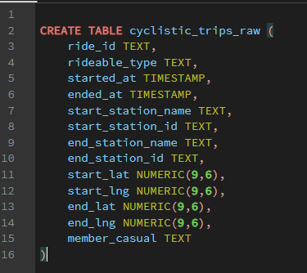
Tools selected:
- Excel — for preliminary correction of the CSV structure using the “Text to Columns” feature.
- PostgreSQL — for storing, validating, cleaning, and transforming data.
- Later, Tableau / Power BI / Excel charts — for visualization during the Share and Act phases.
Why these tools:
- Excel helped resolve the import issue and restore the correct column structure
- PostgreSQL is suitable for working with large volumes of data, performing data quality checks, and creating calculated fields
- SQL provides a reproducible and professional workflow for the portfolio
Data structure and initial validation
Before cleaning, the dataset structure and data types were reviewed.
- The table schema and column data types were inspected
- A preview of the dataset was performed using sample queries
- The total number of rows was verified
This step ensured that the dataset was loaded correctly and that key fields (ride_id, timestamps, user type) had appropriate data types for further analysis.

3.2 Data’s integrity steps
(MORE in Documentation of any cleaning or manipulation of data)

3.2.1 Duplicate and corrupted identifiers
A check for duplicate ride_id values revealed 3,785 duplicated entries.
Further investigation showed that:
- These were not true duplicates (other fields differed)
- The ride_id values were stored in scientific notation (e.g., 7.99E+14)
- This indicates corruption during preprocessing (likely Excel formatting)
As a result:
- The primary identifier (ride_id) became unreliable for these rows
- These records were excluded from the dataset
After removal:
- 3,785 rows were deleted
- Final dataset size: 5,597,877 rows
Given the negligible proportion of affected data, this decision does not impact overall analysis quality.

3.2.2 Missing values
Key columns were checked for missing values, including:
- ride_id
- started_at
- ended_at
- member_casual
No critical missing values were identified that would compromise the analysis.

3.2.3 Categorical data validation
The member_casual column was inspected to ensure:
- Only valid categories are present
- No unexpected or malformed values exist
This ensures correct segmentation between user types.

3.2.4 Date range validation
The dataset was checked for:
- Valid date ranges
- Consistency of timestamps
This ensures that all records fall within the expected timeframe and no temporal anomalies are present.

3.2.5 Trip duration validation
Before feature creation, trip durations were evaluated to detect anomalies.
A validation check identified 29 records where:
ended_at <= started_at
These represent logically impossible trips.
Data cleaning
Removal of invalid trip durations
The invalid records were removed.
A validation query confirmed that no such records remained.
This step ensures:
- Accurate duration calculations
- No distortion in time-based analysis

3.2.6 Data transformation
1. Ride length
A new column ride_length was created to store trip duration:
The INTERVAL data type allows precise representation of time differences.
2. Day of week
A new column day_of_week was created.
This enables analysis of user behavior across different days.
Note: PostgreSQL returns values from 0 (Sunday) to 6 (Saturday), which differs from Excel’s 1–7 system.
Data validation after transformation
The newly created features were validated using sample queries to ensure:
- ride_length is correctly calculated
- day_of_week aligns with actual calendar dates
Documentation and reproducibility
All cleaning and transformation steps were performed using SQL queries and documented throughout the process.
This ensures:
- Full reproducibility
- Transparency of data preparation
- Traceability of all transformations

3.2.7 Verifying that the data ready for analysis
The dataset was verified as clean and ready for analysis through a series of post-cleaning checks. These included reviewing table structure and data types, inspecting sample rows, confirming removal of corrupted IDs and invalid trip durations, checking for missing values in key fields, validating category values in member_casual, and testing the newly created variables ride_length and day_of_week. These steps confirmed that the dataset was consistent and suitable for analysis.
- ANALYZE
All operations are written in details in following documentation (WORD “analyses”)

4.1 Descriptive analysis
1. Total Number of Trips
- Total trips: 5,597,848
This means that after cleaning the data I have complete and very large dataset for analysis.
2. Distribution by user type
- member: 3,585,751
- casual: 2,012,097
In other words, members take significantly more trips than casual riders.
First conclusion Members account for the bulk of the service’s usage. This makes sense: subscribers use Cyclistic more often and more regularly.
3. Average ride duration
- Overall average duration: 16.10 minutes
4. Maximum and minimum durations
- max ride_length: 1 day 02:14:54
- min ride_length: 00:00:00.046
5. The Most Frequent Day of the Week
Based on the number of trips, trend is:
- day_of_week = 6 = This is Saturday (by PostgreSQL)
- Number of trips: 867,819
Conclusion: Saturday is the busiest day in terms of total trips. This is a strong indication:
- the service is used intensively on weekends
- leisure / non-commuting behavior likely matters a lot
Compare members vs casual analysis
6. Average trip duration by segment
- casual: 22.63 min
- member: 12.43 min
Insight:
- Casual riders ride significantly longer than members.
- The difference is huge: about 10.2 minutes longer.
What this might mean:
Most likely: Members use bikes more often as practical transportation:
- commuting
- short routine trips
Casual riders use bikes more often for leisure:
- longer leisure rides
- weekend outings
- occasional city exploration
This is direct evidence for answering the main business question - Annual members and casual riders use Cyclistic differently.
7. Average trip duration by day of the week
Casual | Member
Sun (0): 26.19 | Sun (0): 13.71
Mon (1): 22.44 | Mon (1): 12.03
Tue (2): 19.81 | Tue (2): 12.02
Wed (3): 18.75 | Wed (3): 11.90
Thu (4): 19.85 | Thu (4): 11.97
Fri (5): 22.57 | Fri (5): 12.42
Sat (6): 25.27 | Sat (6): 13.58

For casual riders:
There is a very clear weekend effect:
- the longest rides are on Sunday and Saturday
- during the middle of the week, ride duration is noticeably lower
For members:
The pattern is much more stable:
- It stays around 12 minutes for almost the entire week
- There is an increase on weekends, but it’s small
Conclusion:
Casual riders use the service more recreationally and “on weekends,” while members use it more consistently and utilitarianly throughout the week.
8. Number of trips by day of the week
Casual | Member
Sun: 333,752 | Sun: 382,496
Mon: 230,277 | Mon: 506,052
Tue: 228,009 | Tue: 574,121
Wed: 223,082 | Wed: 559,095
Thu: 258,689 | Thu: 578,189
Fri: 322,602 | Fri: 533,665
Sat: 415,686 | Sat: 452,133

What this shows:
Casual riders
- Peak usage: Saturday
- followed by Sunday and Friday
In other words, the casual segment clearly gravitates toward weekends and the days leading up to them.
Members
- Peak usage: Thursday
- followed by Tuesday / Wednesday / Friday
In other words, members are more active specifically on weekdays.

Key conclusion
Members use bikes more as a regular mobility solution during the workweek, while casual riders show a leisure-oriented, weekend-heavy pattern.

4.2 Monthly analysis

4.2.1 Overall Travel Trends
- January–February: Very low activity (~137k → 201k)
- March–April: Growth (~298k → 371k)
- May–August: peak (up to ~789k in August)
- September–October: decline (~714k → 645k)
- November–December: sharp drop (~356k → 140k)
Conclusion:
Strong seasonality—demand rises sharply in the summer and falls in the winter.

4.2.2 User behavior (member vs. casual)
In all months:
- Members always have more trips
Conclusion:
- Members = regular users
- Casual = more situational (but become very active in the summer)

4.2.3 Average trip duration
Insight:
- Casual users always ride longer
- Members ride shorter and more consistently
Conclusion:
- casual = leisure / strolls
- member = commuting / quick trips

4.2.4 Duration trends by month
- increase in duration toward summer (peak: June–July)
- then a gradual decrease toward winter
Conclusion:
the better the weather → the longer the trips

4.3 Seasonal Analysis

4.3.1 Number of trips
- Summer: ~2.23M (maximum)
- Autumn: ~1.71M
- Spring: ~1.17M
- Winter: ~0.48M (minimum)
Conclusion: Summer is the key business season

4.3.2 Average trip duration
- Summer: ~17.95 min (maximum)
- Spring / Autumn: ~15 min
- Winter: ~12.79 min (minimum)
Conclusion:
- In summer, people take longer trips
- In winter, trips are quick and to the point

4.3.3 User behavior by season
Casual:
- Summer: ~952k (very sharp spike)
- Winter: ~94k (almost none)
Member:
- more consistent, but also growing in summer
Key insight: seasonality has a stronger impact on casual users than on members

4.4 Bike Type Analysis

4.4.1 Bike Type Usage (Volume)
Casual:
- electric_bike → ~1.33M
- classic_bike → ~0.68M
Electric bikes are roughly twice as popular
Member:
- electric_bike → ~2.31M
- classic_bike → ~1.28M
Same pattern (electric bikes lead)
Conclusion: Electric bikes are the dominant type for both groups But Members use them significantly more often in absolute terms

4.4.2 Behavior: Trip Duration
Casual:
- classic_bike → 39.65 min
- electric_bike → 14.02 min
Member:
- classic_bike → 14.95 min
- electric_bike → 11.03 min
Key Insight
- Classic bikes = long trips (especially for casual users)
- Electric bikes = short/practical trips

4.4.3. Overview by bike type
- electric_bike → 3.64 million trips
- classic_bike → 1.95 million
Electric ≈ 65% of all trips
Average duration:
- classic → 23.49 min
- electric → 12.13 min
Key Insight
- Electric bike = mass transit (efficiency, convenience)
- Classic bike = leisure / long trips

4.5 Summarize insights
1. Members generate more rides overall
They account for the bulk of rides.
2. Casual riders take much longer rides
22.63 minutes versus 12.43 minutes for members.
3. Casual riders are weekend-oriented
Both in terms of the number of rides and their duration.
4. Members are weekday-oriented
Their usage is more regular and resembles commuting or routine mobility.
5. Pronounced seasonality
- The business is highly dependent on the weather
- Summer is the main driver of revenue
6. Different user behaviors
- Casual: Take longer trips, Highly dependent on the season , Peak season is summer
- Member: Travel more frequently, Take shorter trips, More consistent
7. Type of service usage
- members → utilitarian use (commuting)
- casual → recreational use (leisure, tourism)
8. Summer = a window for conversion
The most important conclusion for the business:
- there are many casual users
- they actively use the service
which means - this is the best time to convert them to membership
9. Behavioral segmentation
Member:
- use bikes as transportation
- more often electric
- short rides
- consistent year-round
Casual:
- use bikes for experience / leisure
- long rides
- especially on classic bikes
- strong seasonality
10. Core insight
Casual riders already demonstrate high engagement during peak seasons through longer and leisure-oriented rides, indicating strong potential for conversion into annual members if the value proposition aligns with their usage behavior.
- SHARE
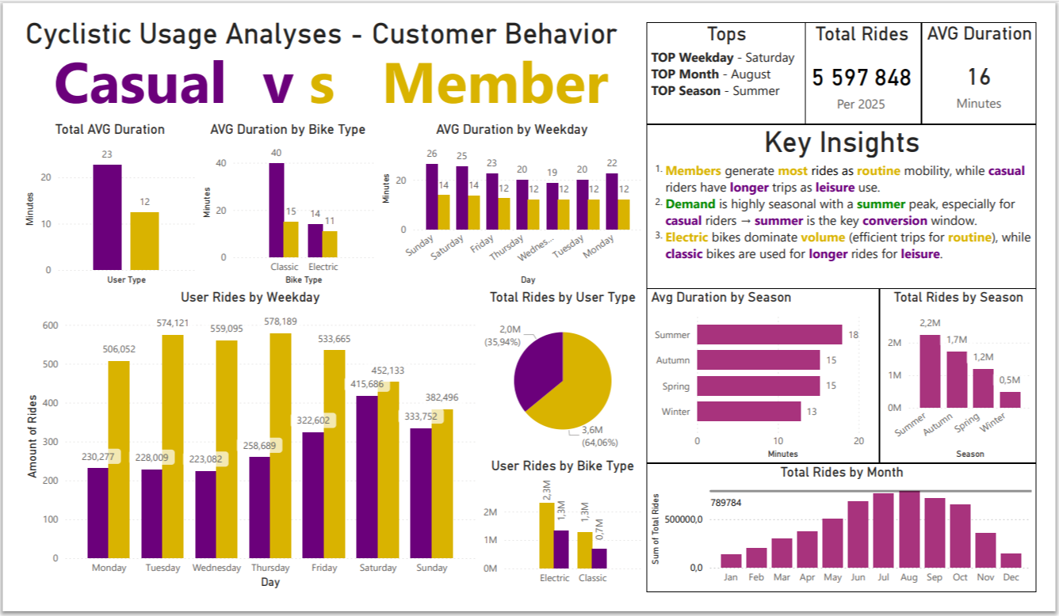
- ACT

6.1 Final Conclusion
Based on the full analysis, Cyclistic users demonstrate two fundamentally different behavioral patterns:
- Annual members use the service as a routine mobility solution — they ride frequently, consistently throughout the week, and prefer shorter trips.
- Casual riders use the service primarily for leisure and recreation — they take longer rides, are highly active on weekends, and their usage is strongly dependent on seasonality.
The most critical finding is that casual riders show high engagement during peak periods (especially summer), which creates a strong opportunity for conversion into annual members.
This directly answers the business question and confirms that conversion strategies should focus on aligning membership value with leisure-oriented behavior.
How the Business Can Apply These Insights
These insights can be directly used by the marketing team to:
- Segment users behaviorally (not just by subscription type)
  - Members → routine / commuting
  - Casual → leisure / experience
- Design targeted marketing strategies
Instead of generic campaigns, Cyclistic can create:
  - seasonal campaigns
  - behavior-based offers
  - product-specific messaging (e.g., electric vs classic bikes)
- Optimize timing of campaigns
The analysis clearly shows:
  - Summer = peak engagement window
  - Weekends = key touchpoints for casual users
This means marketing efforts should be time-sensitive and behavior-driven, not static.

6.2 Top 3 Business Recommendations
1. Launch Seasonal Conversion Campaigns (Focus on Summer)
Rationale:
Casual rider activity peaks dramatically in summer (~952K rides), making it the highest-opportunity conversion period.
Action:
- Launch targeted summer campaigns promoting membership benefits
- Offer limited-time discounts or trial memberships
- Highlight cost savings for frequent seasonal users
Expected impact:
Maximize conversion when users are most engaged and already actively using the service.
2. Position Membership as a Leisure Value, Not Only Commuting
Rationale:
Casual riders are not commuting — they are riding for leisure, longer durations, and experiences.
Action:
- Reframe messaging:
  - not just “save money on commuting”
  - but “unlock unlimited rides for exploration and weekends”
- Promote:
  - long rides
  - city exploration
  - weekend activities
Expected impact:
Better alignment with user motivation → higher conversion likelihood.
3. Promote Electric Bikes as Entry Point to Membership
Rationale:
Electric bikes dominate usage (~65% of all rides) and are associated with shorter, practical trips.
Action:
- Offer:
  - discounts on electric bike usage for members
  - “upgrade your ride” campaigns
- Position membership as:
  - convenience
  - speed
  - accessibility
Expected impact:
Encourage habit formation → transition from casual usage to routine usage.

6.3 Next Steps
To build on these findings, the following actions are recommended:
- Run A/B tests on marketing campaigns
  - Compare seasonal vs. non-seasonal offers
  - Test messaging (leisure vs commuting)
- Develop customer journey tracking
  - Identify when casual riders are most likely to convert
  - Analyze repeat behavior patterns
- Integrate digital marketing channels
  - Use email, mobile apps, and push notifications
  - Target users during weekends and summer periods
Additional Data That Could Improve the Analysis
While the current dataset provides strong behavioral insights, additional data could significantly enhance decision-making:
- User demographics (age, location, income)
- Trip purpose data (commuting vs leisure)
- Customer lifetime value (CLV)
- Marketing campaign data (conversion rates, CTR, etc.)
This would allow:
- more precise segmentation
- predictive modeling
- ROI-driven marketing strategies
Portfolio & Presentation
This case study demonstrates:
- Full data analytics workflow (SQL → Analysis → Visualization)
- Ability to translate data into business insights
- Strong storytelling through Power BI dashboard
The project is portfolio-ready and can be presented to stakeholders or recruiters as a complete data analytics case.

